**Assg-04 GUI Calculator**

**Esraa Abdelmoein**

**2025-09-27**

**Mobile application development- Android**

**Russell Shanahan**

Make Your Calculator Application support the 4 different Android screen densities....(for example, hdpi, mdpi, xhdpi, xxhdpi):

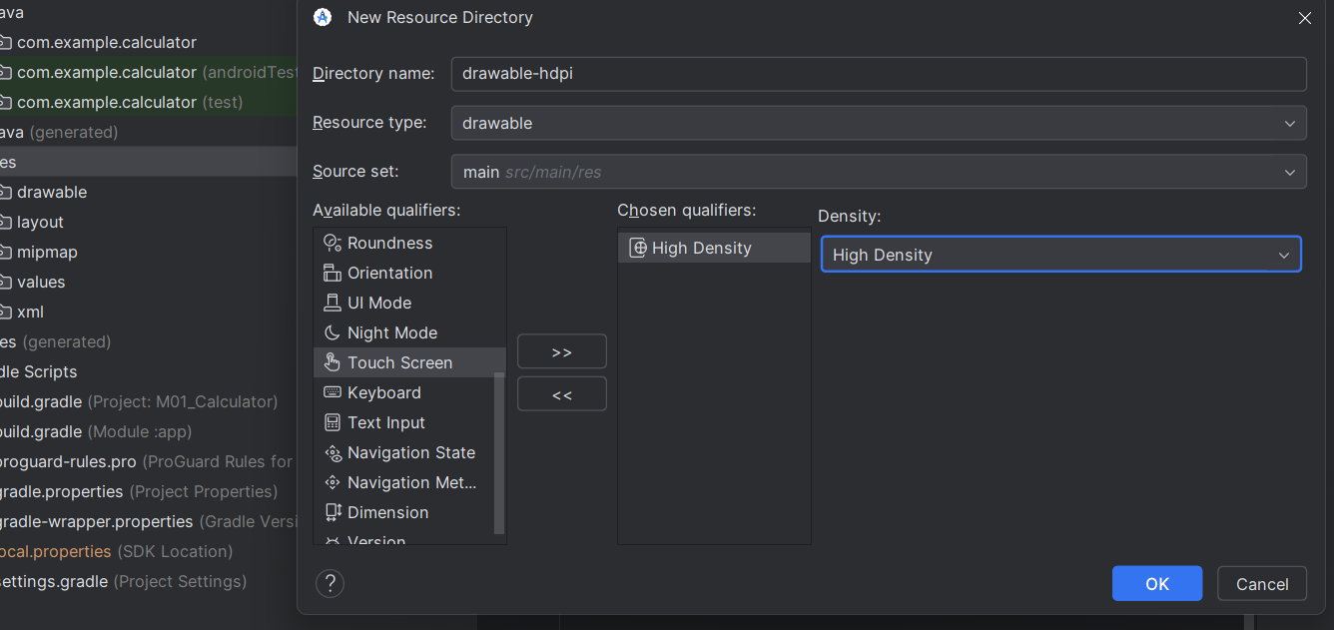

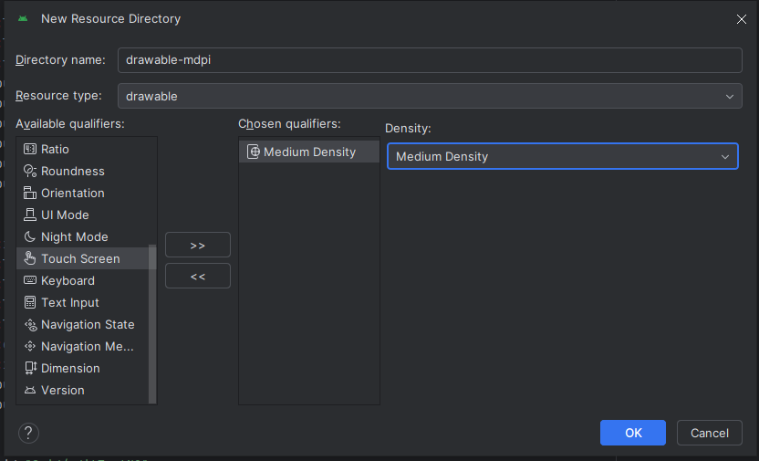

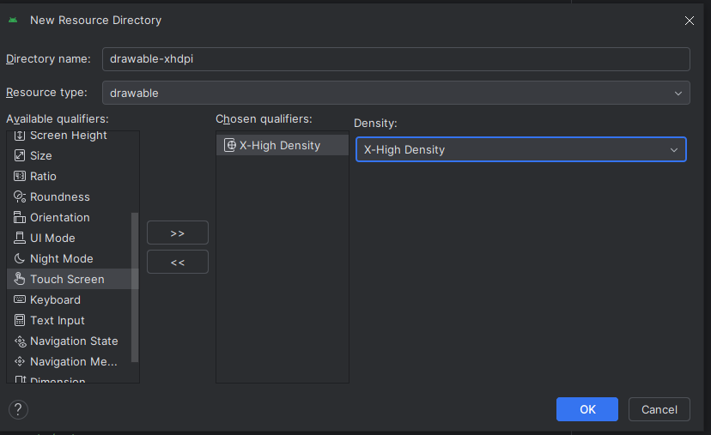

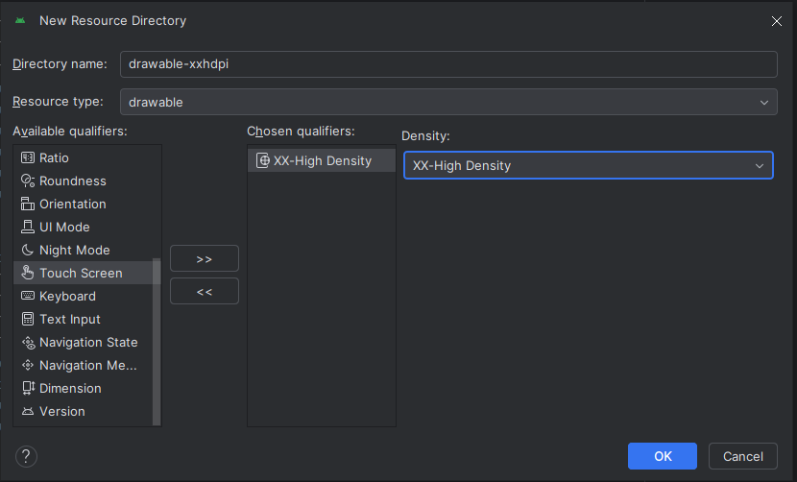

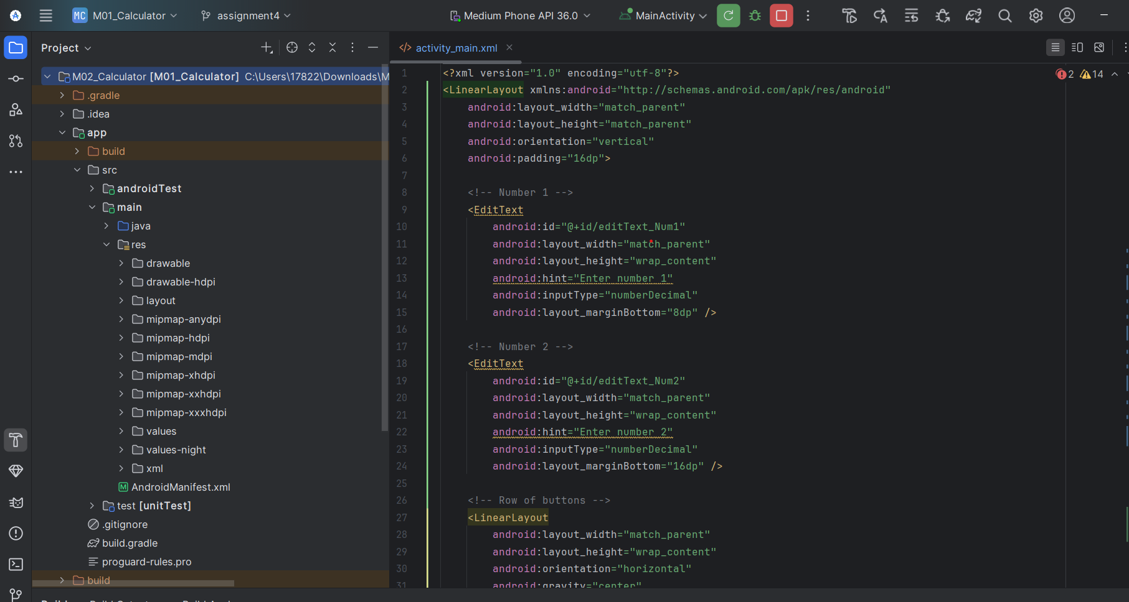

**Create new vector assets:**

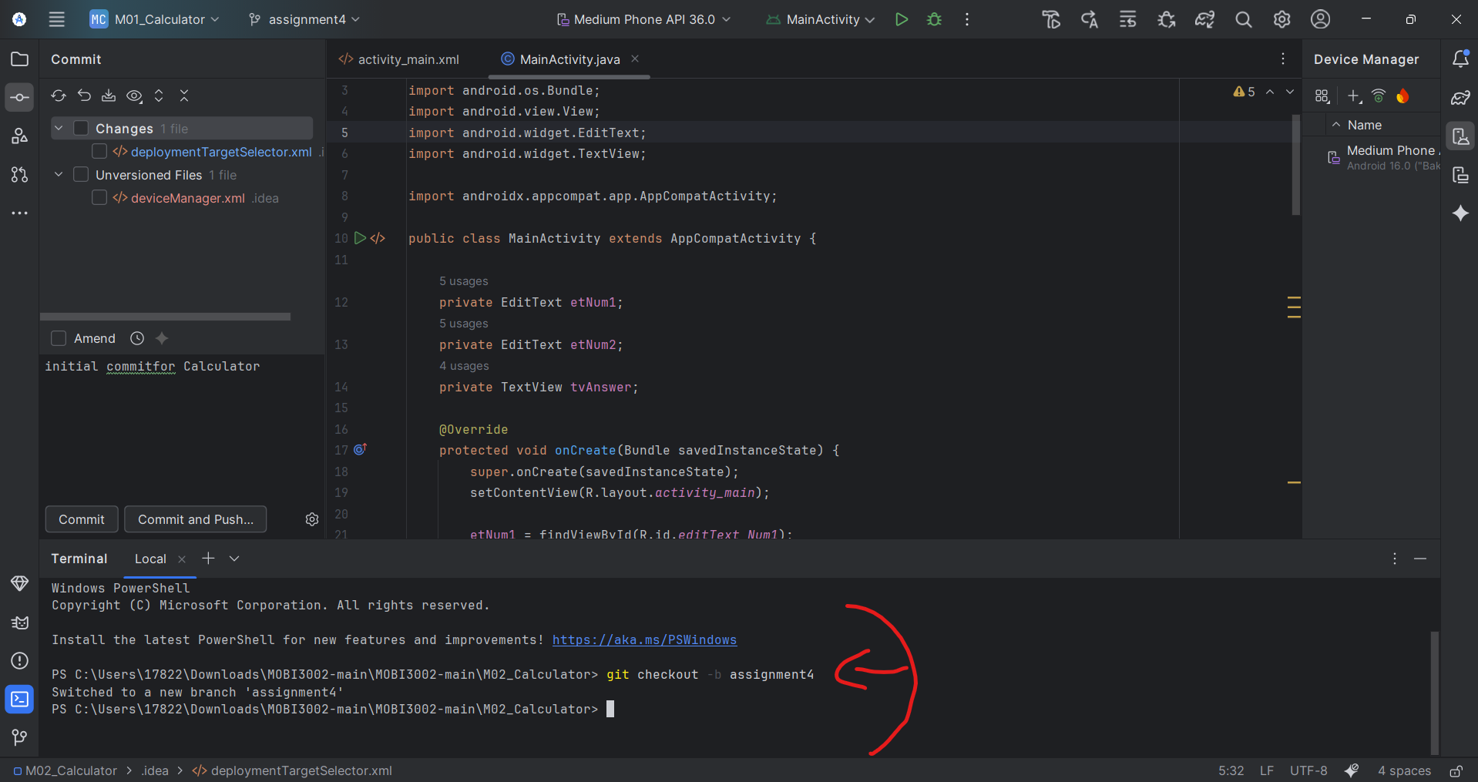

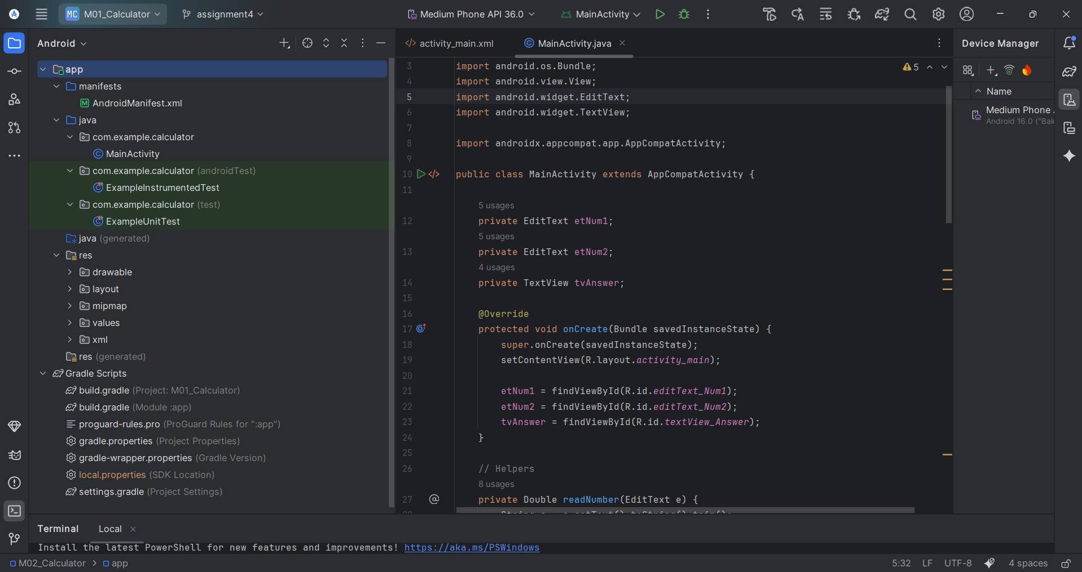

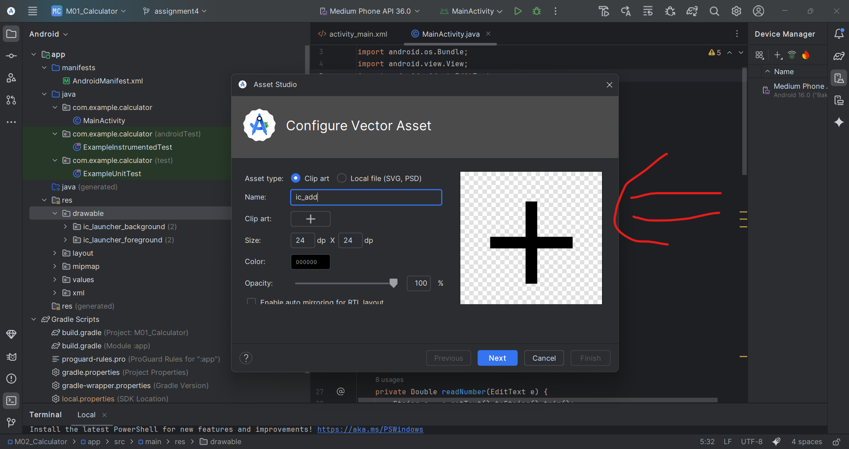

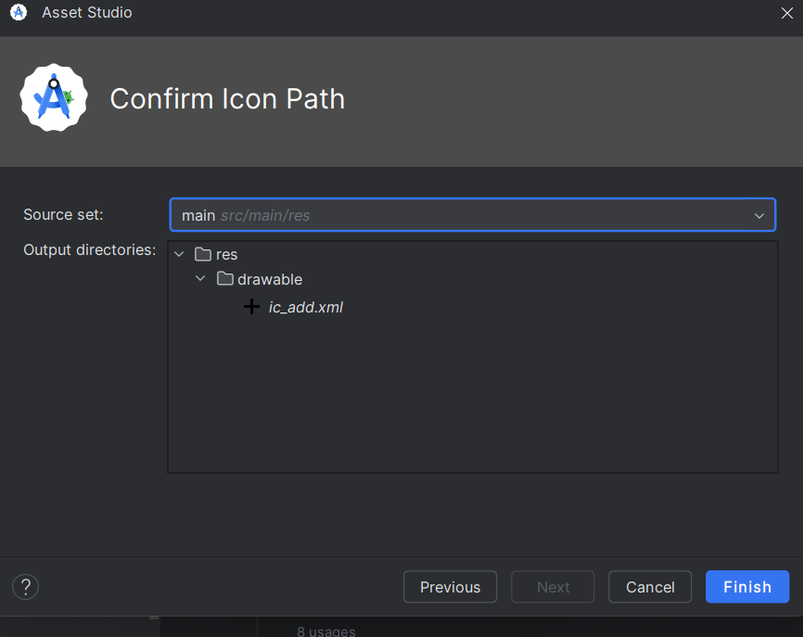

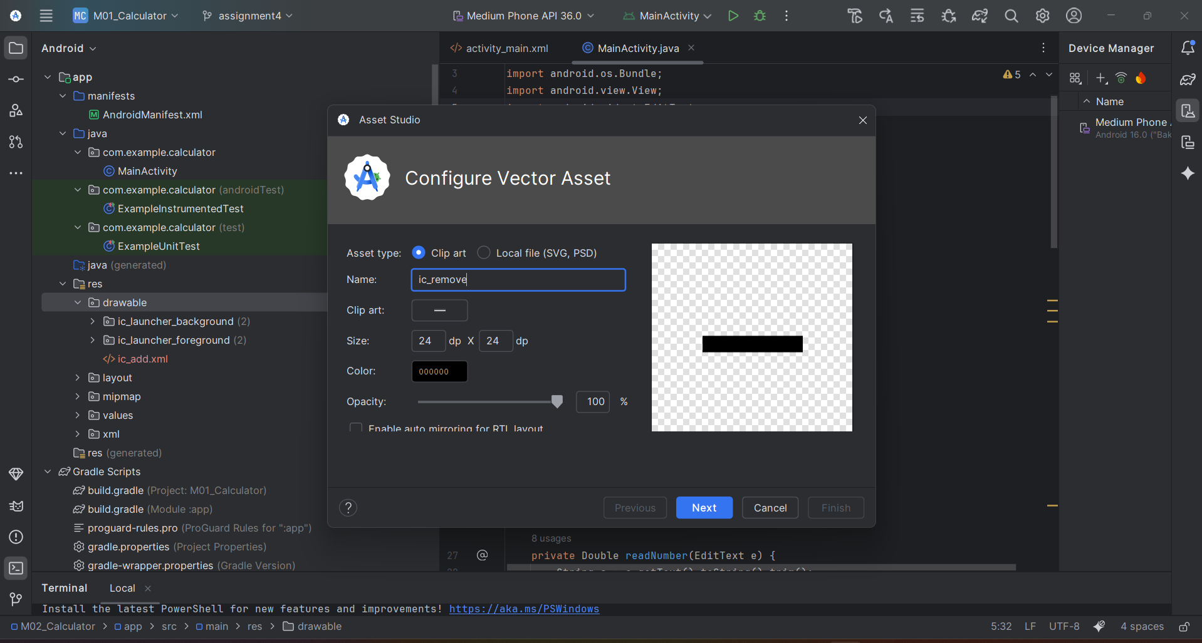

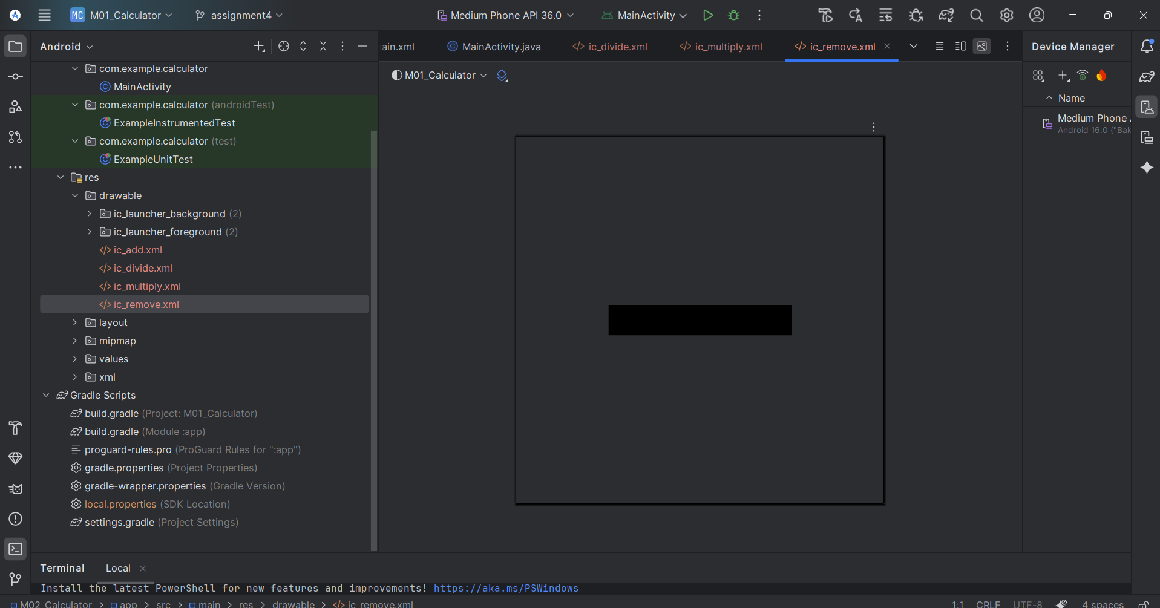

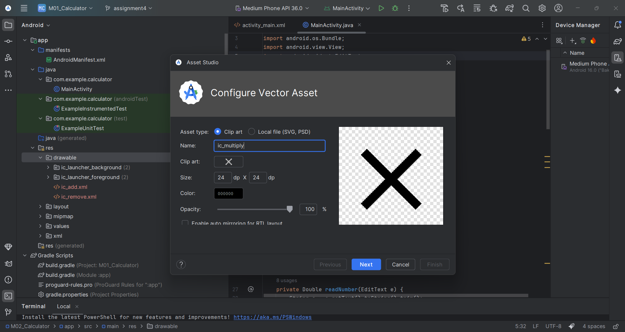

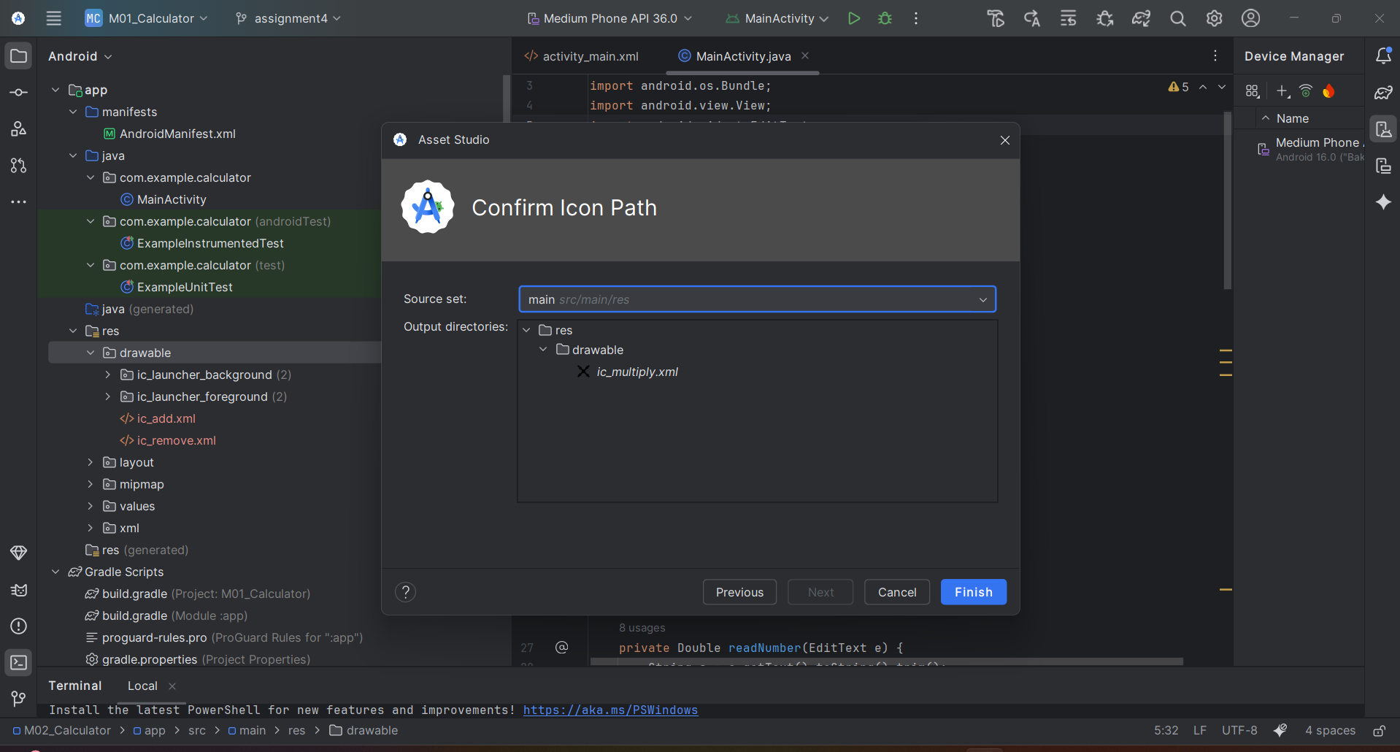

Ok, so I tried to find a divide symbol in the material icons but it was not available. So I created a custom vector icon using XML. The code draws one horizontal line and two small circles, one above and one below, to represent the divide symbol.

Here’s my code that I use to draw divide symbol:

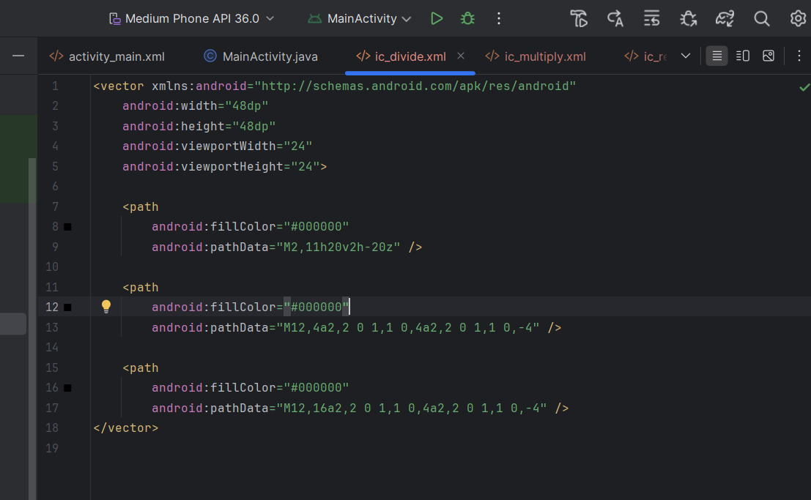

And here’s a design for divide symbol:

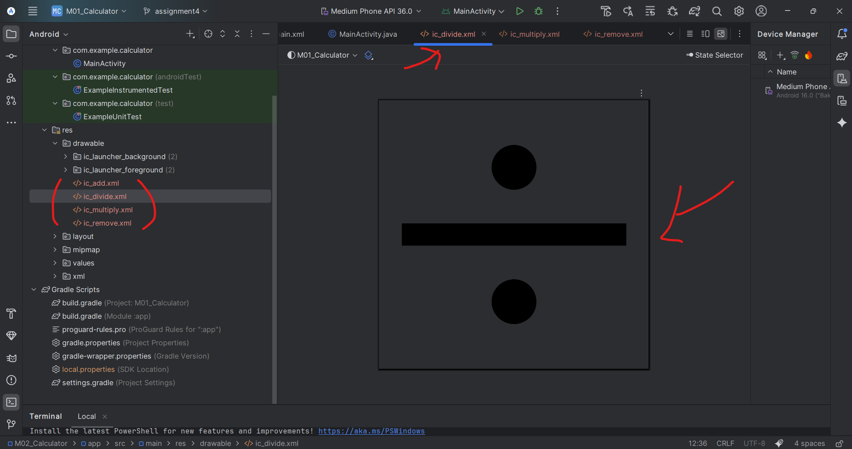

Here, I fixed my activity_main.xml and added image button codes:

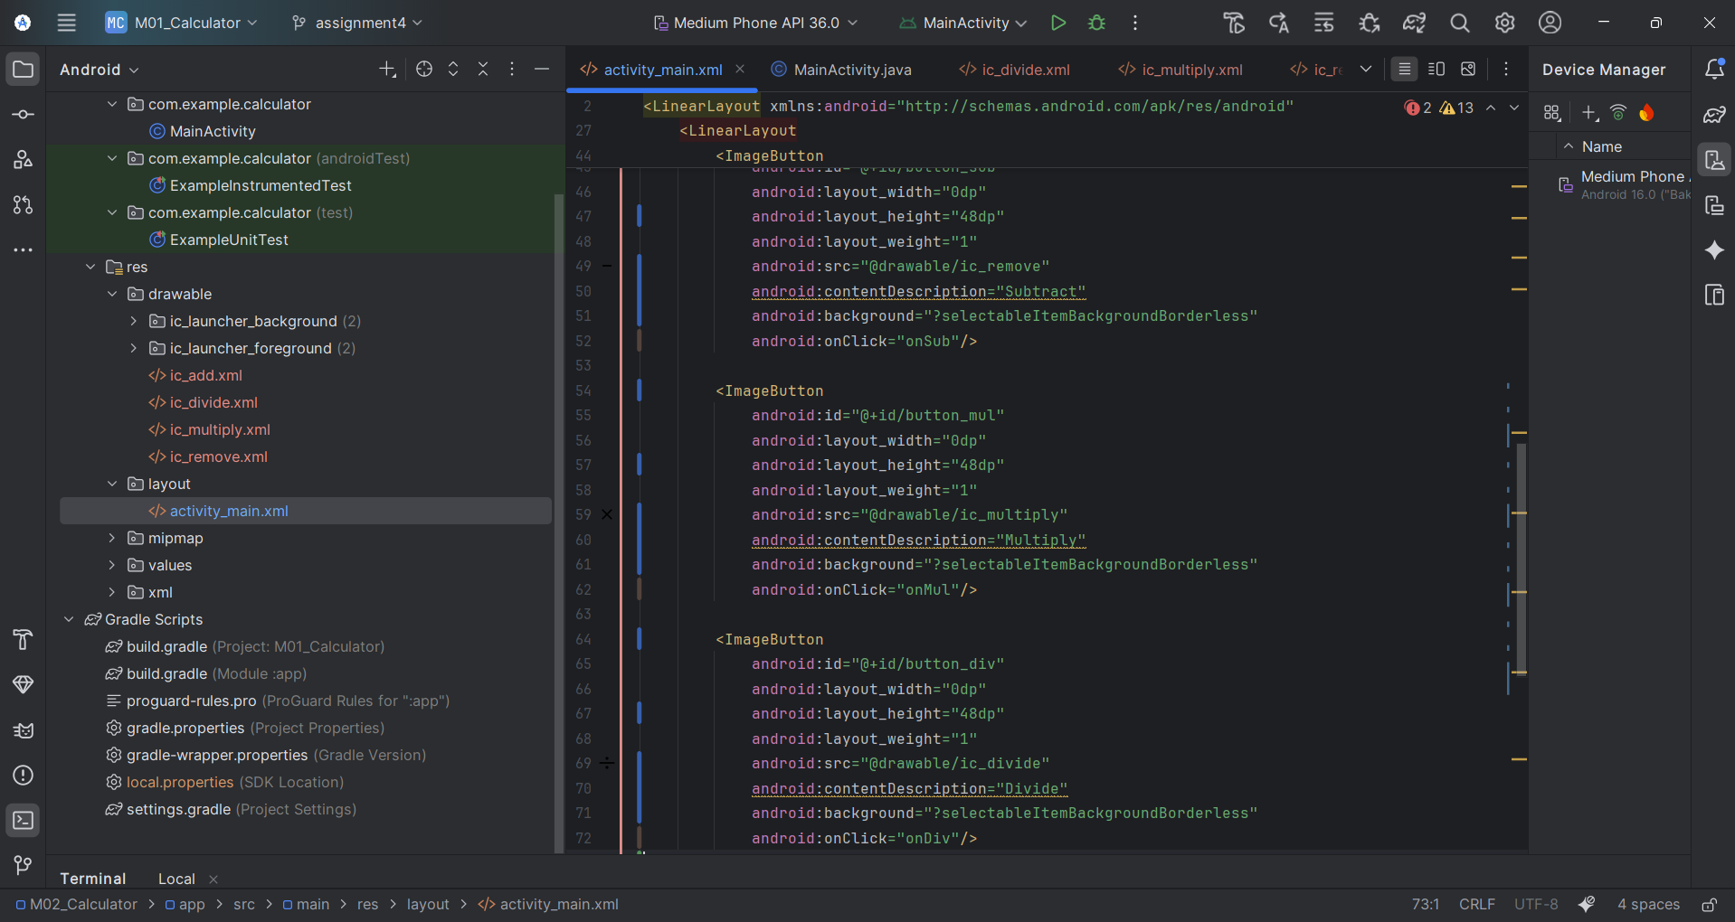

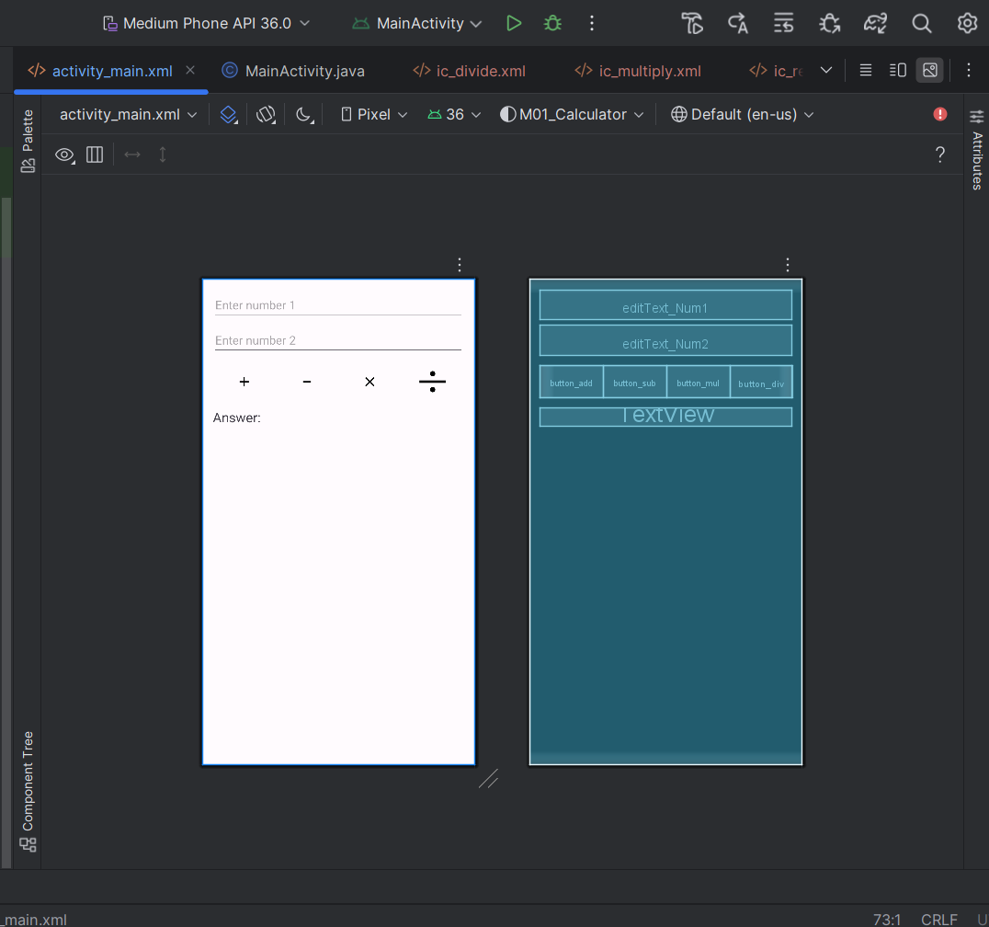

I added the textView to activity main. Xml and running activity main.java and here is the result

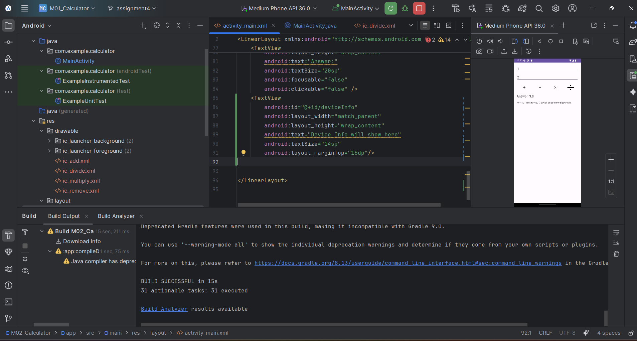

Also I tested divide symbol, and I confirmed those numbers and the result showed correct and it works well:

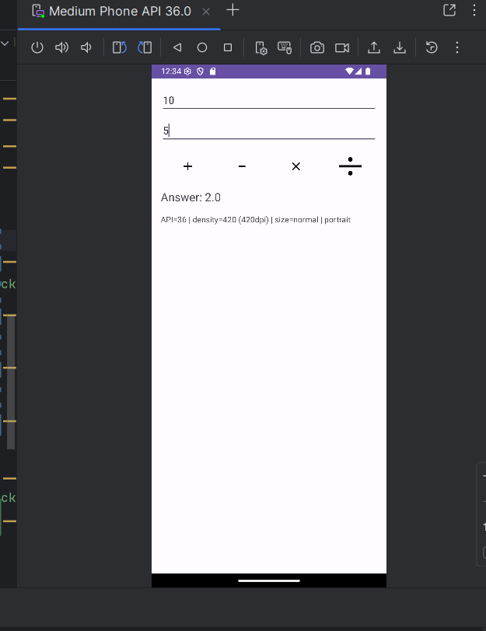

Create a graphic (to display with the calculator) with your name that changes density to match the screen:

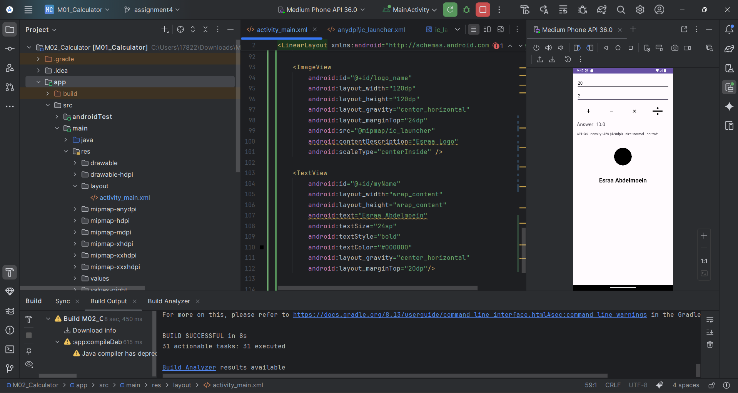

**My Own App Icon (Launcher)**

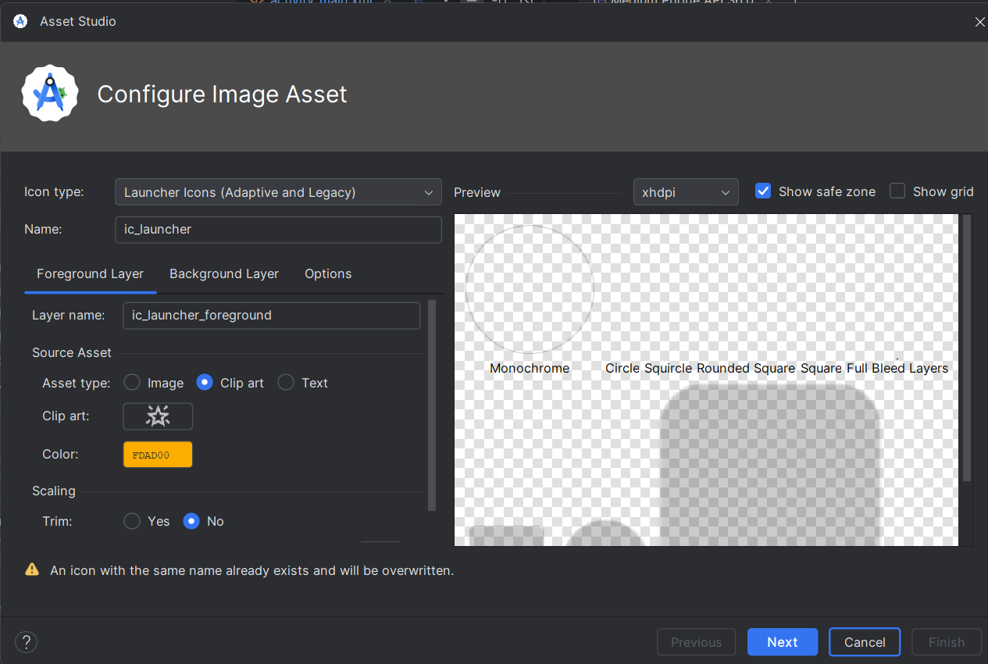

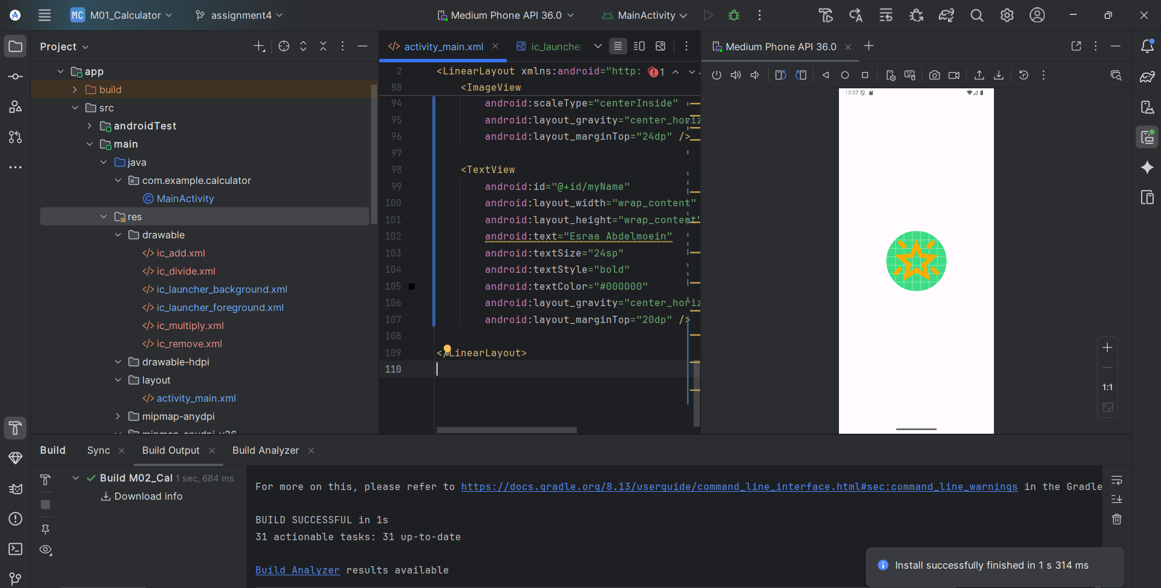

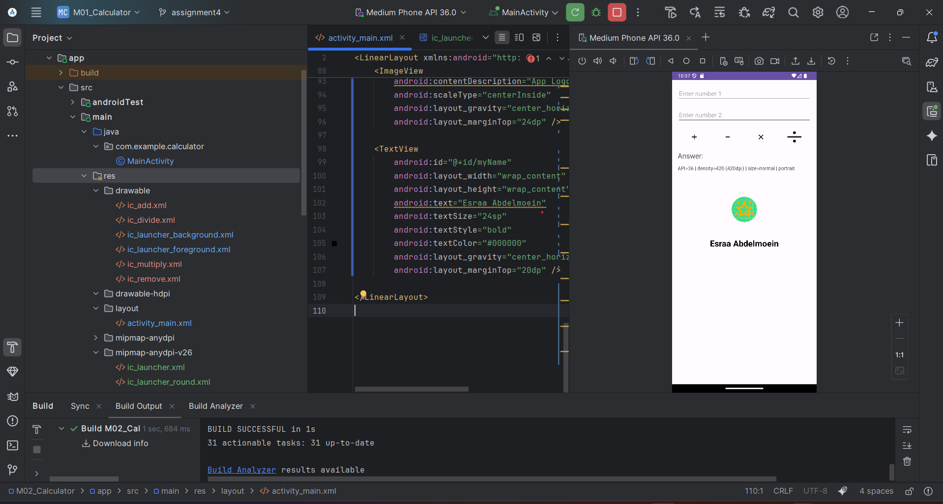

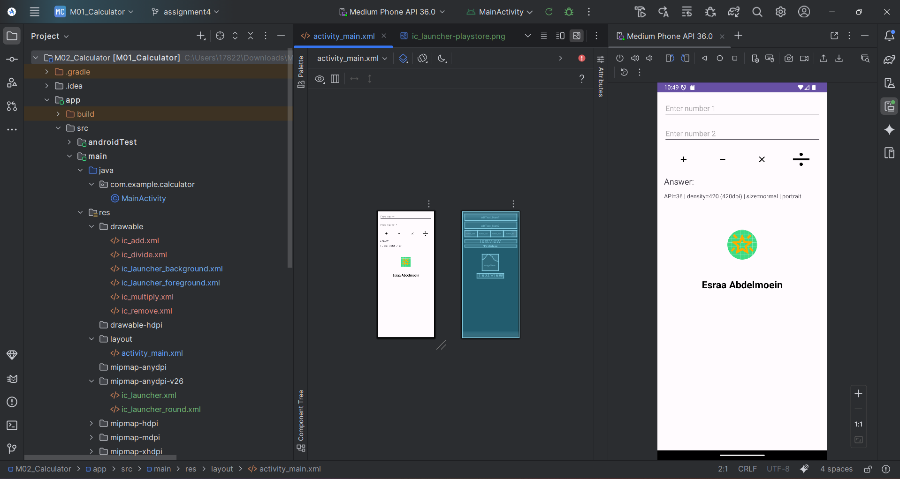

For my Own app icon, I used the Image Asset option in Android Studio. Instead of coding it by hand, I selected a star design from the available shapes. I then adjusted the colors using a bright green for the background and a yellow tone for the stars. This gave me a unique launcher icon that represents my project

**3 different screen sizes**

**Landscape:**

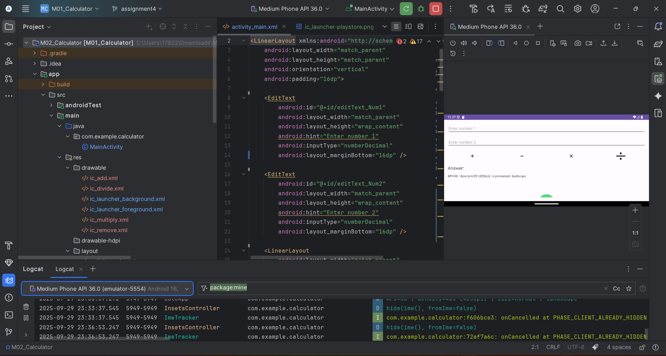

**Tablet:**

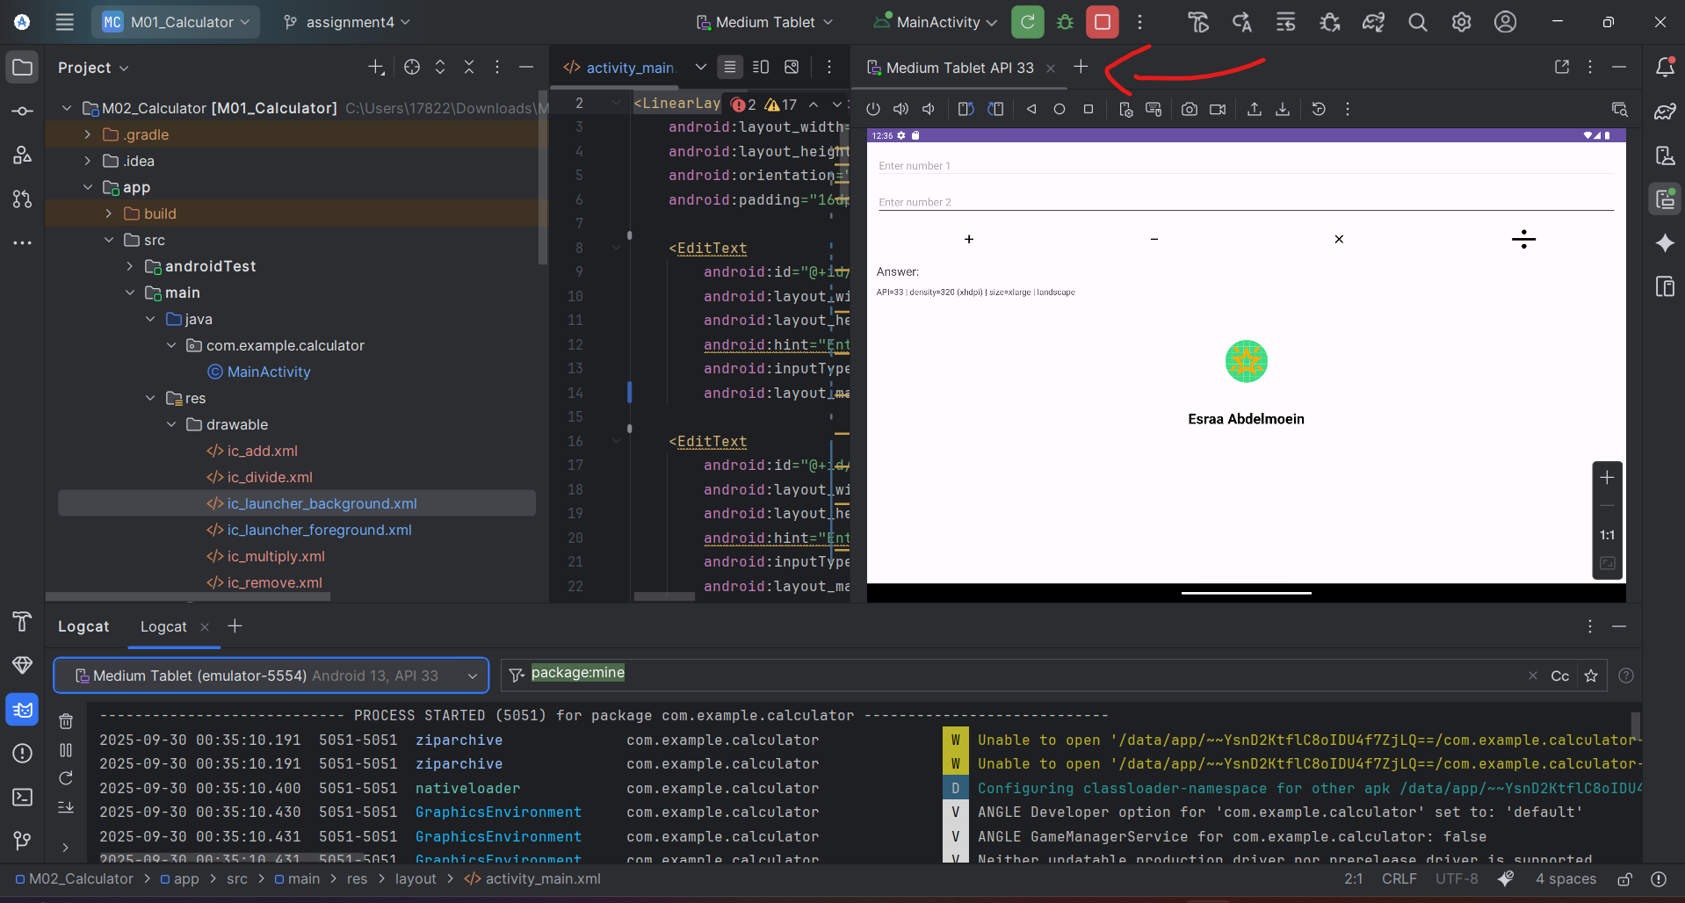

Desktop:

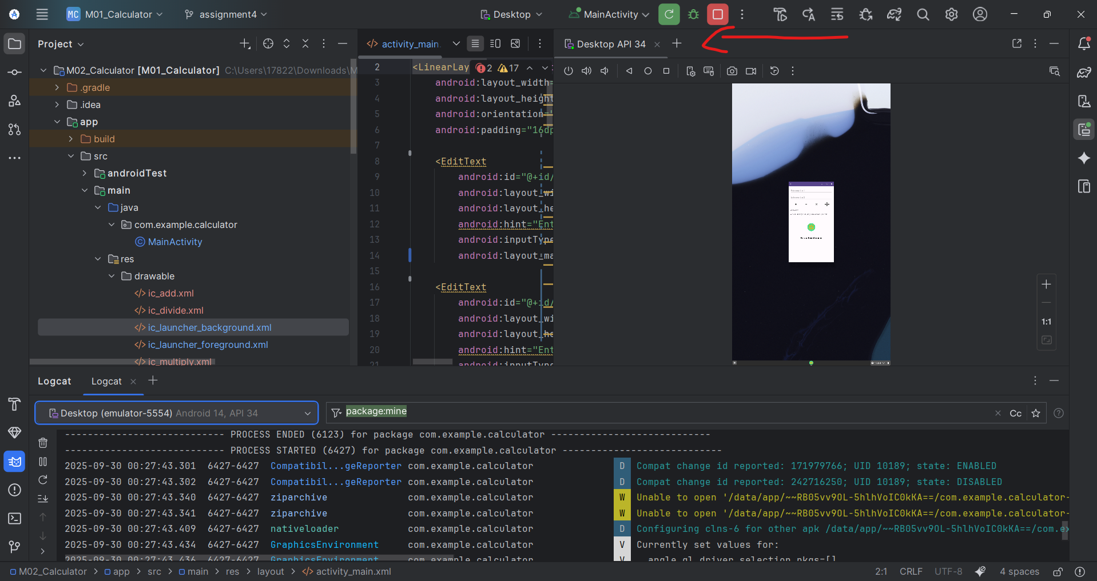

**2 different API-levels on phone:**

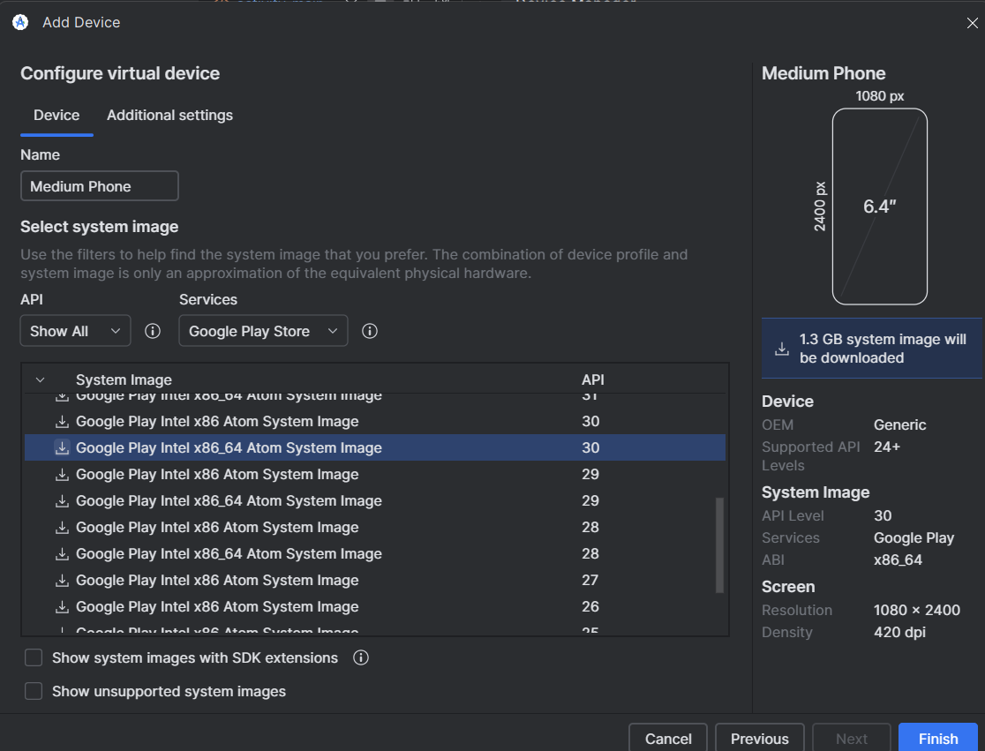

**Portrait size 30:**

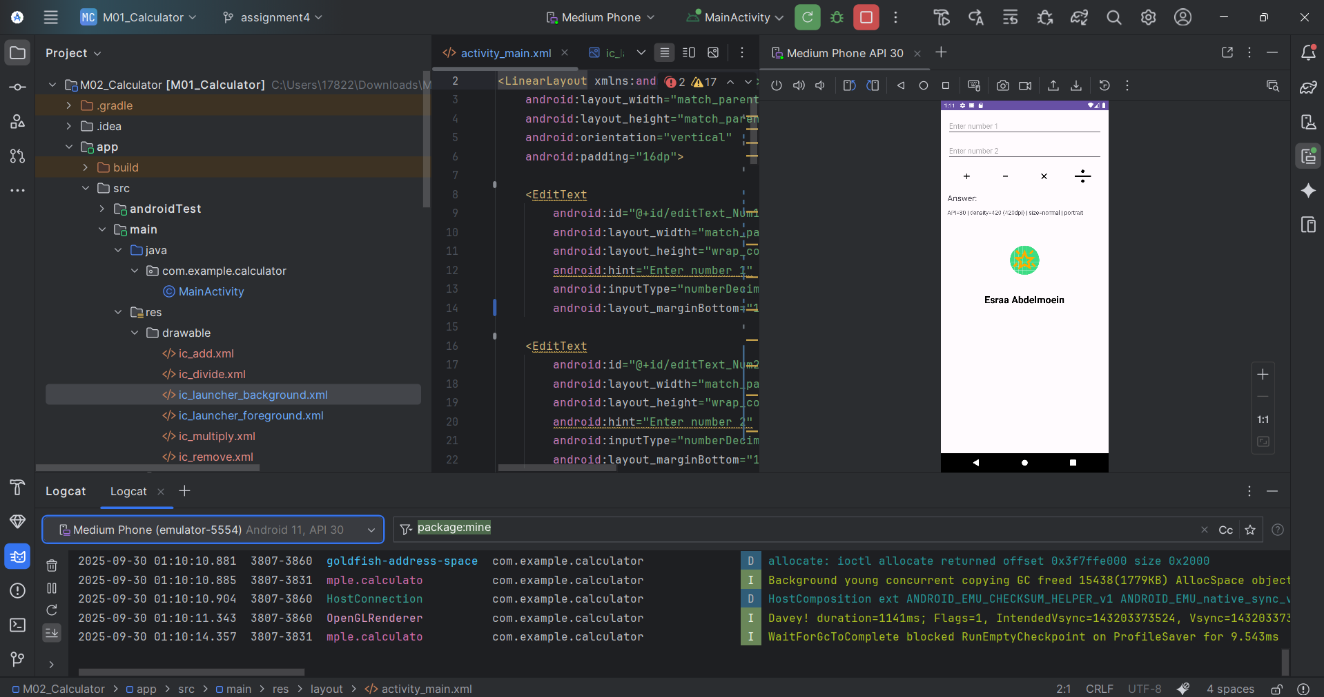

**Landscape size 3o:**

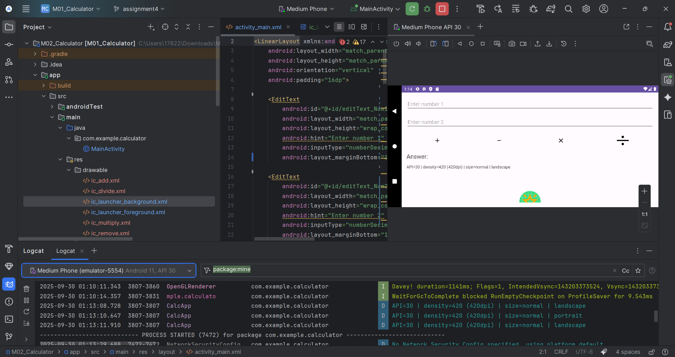

**Portrait size 36:**

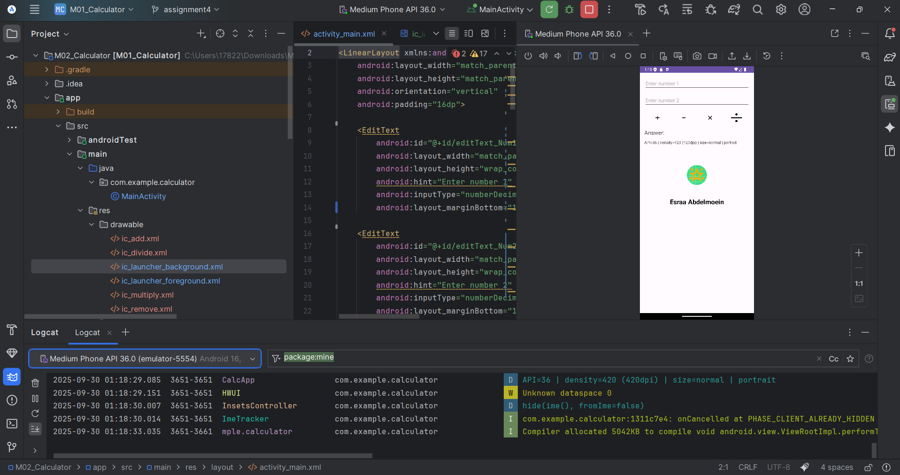

**Landscape size 36:**

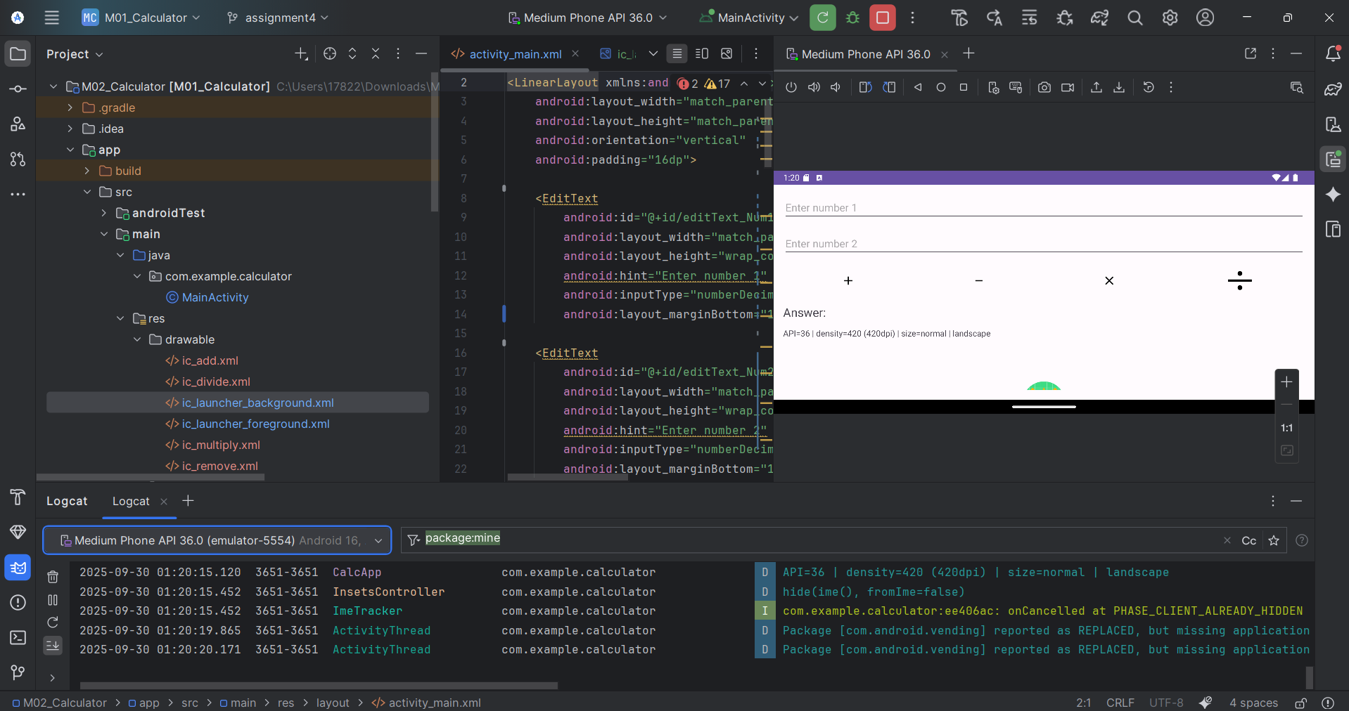

**2 different API-levels on desktop:**

**Large desktop size 33:**

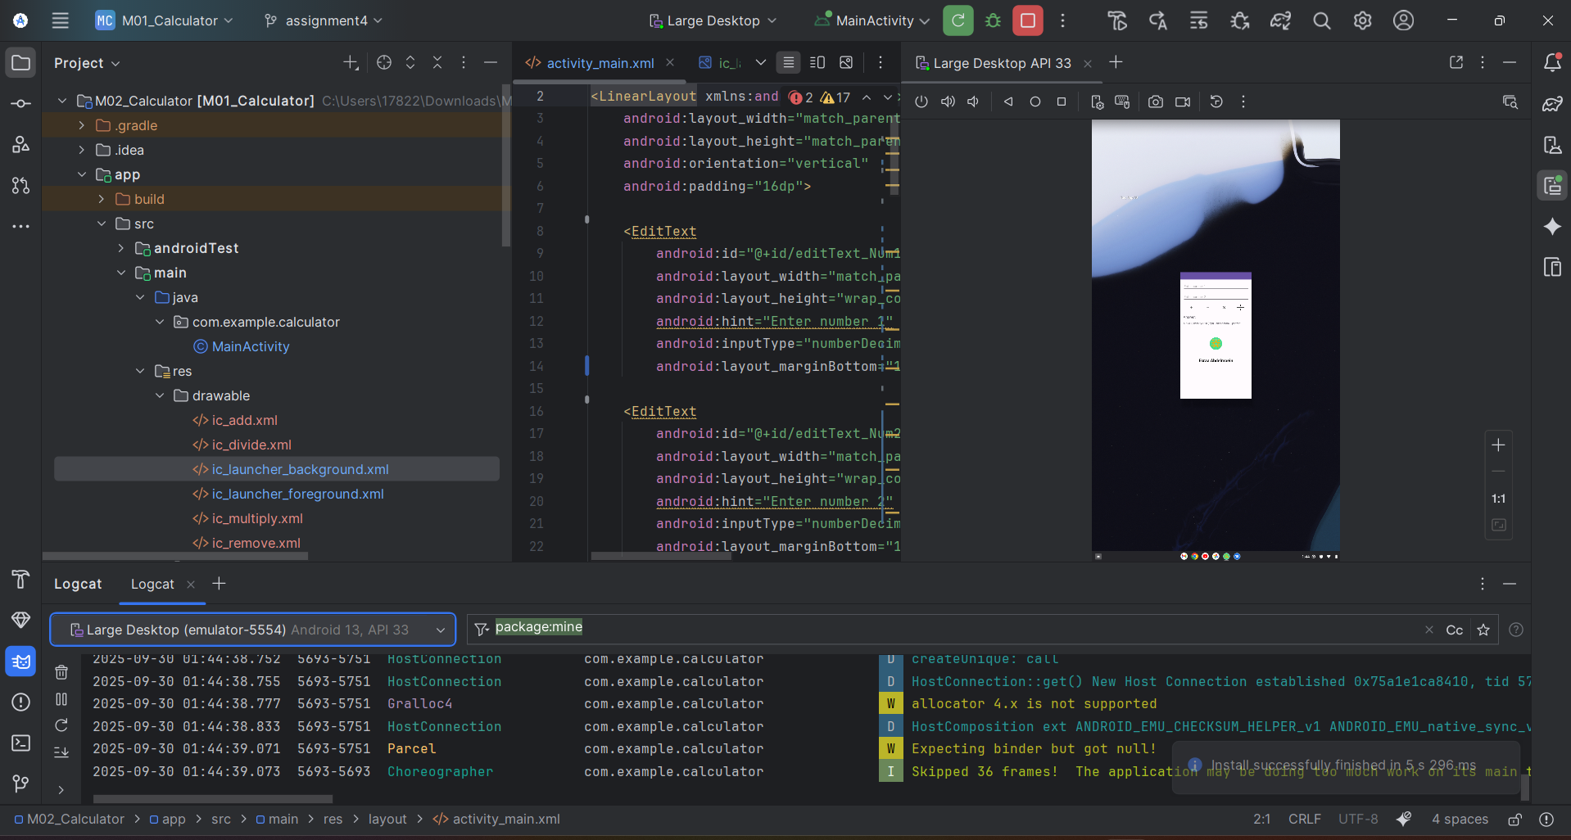

**Desktop size 34:**

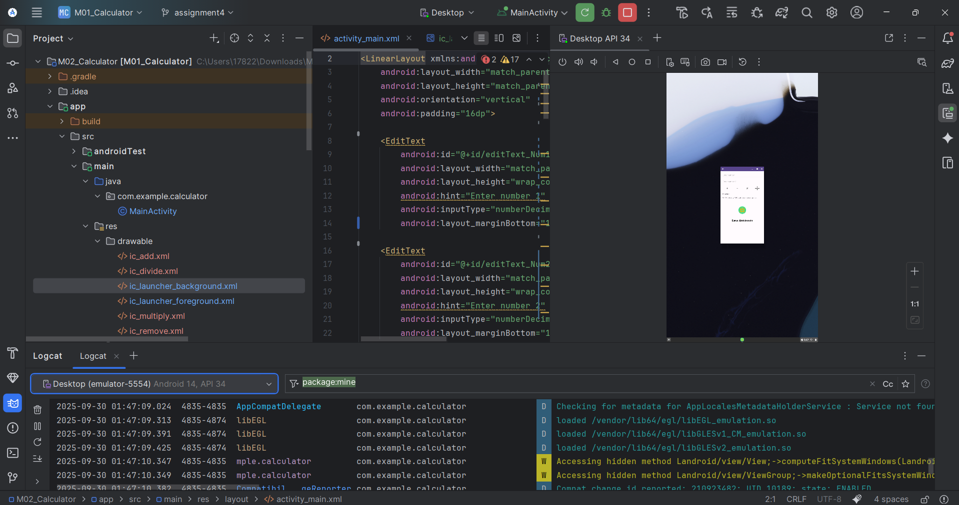

**Logcat:**

